1. According to Chaudhuri et al. , the two dimensional Gaussian matched filter can be expressed as: 𝑓(𝑥, 𝑦) = − 𝑒𝑥𝑝 (− 𝑥 2/ 2𝜎2 ) ∀ |𝑦| ≤ 𝐿/2
2. where 𝜎 is the scale of the filter or the spread of the intensity profile and 𝐿 is the length of the vessel segment having the same orientation
3. The kernel is rotated along 12 possible directions by 15 degree steps to form 12 different templates because the vessels can be oriented in any direction
4. A retinal image is convolved individually by each of the 12 kernels with different orientations and, from the set of these 12 output images, the maximum value for each pixel (x,y) is selected to form the matched filter response image

Concept of matched filter

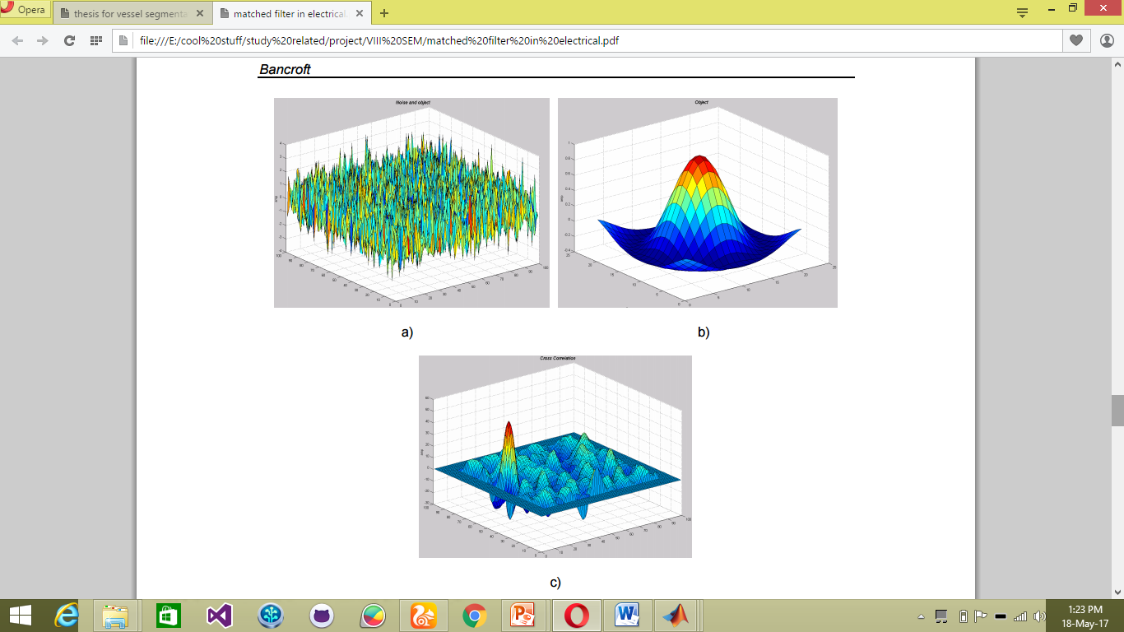

Fig a. shows the noisy input.

b. shows the object to be detected

c. cross correlation of a and b where the object has been detected as the highest peak

why MF

According to Chaudhuri et al., retinal blood vessels possess three different characteristics:

● The blood vessels have small curvatures and may be approximated by piecewise linear segmentation. ● The width of blood vessel decreases when moving away from the optic disk.

● Due to lower reflectance of vessels in comparison to other retinal structures, they seem to be darker compared to the background.

Using matched filtering, image’s features can be detected, which are most similar to a predefined template (whicj we term as KERNEL). Matched filter (MF) has ability to respond to both the vessels’ and non-vessels’ edges

EQUATION EXPLANATION

f(𝑥, 𝑦) = − 𝑒𝑥𝑝 (− 𝑥 2/ 2𝜎2 )

1. It’s a probability function, which yields probability value (i.e. ranges from 0-1).
2. The range of Xis the sub space and exp(x2) gives the mean square value of the total distribution
3. 𝜎2 is the variance which divides the mean square value to give out their probability distribution

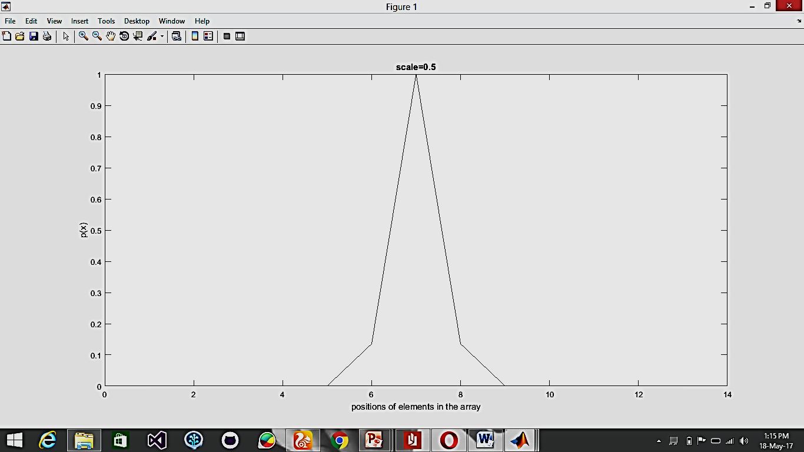

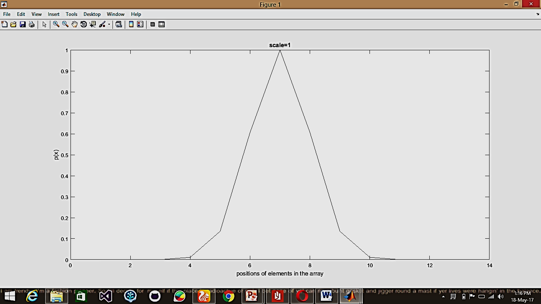

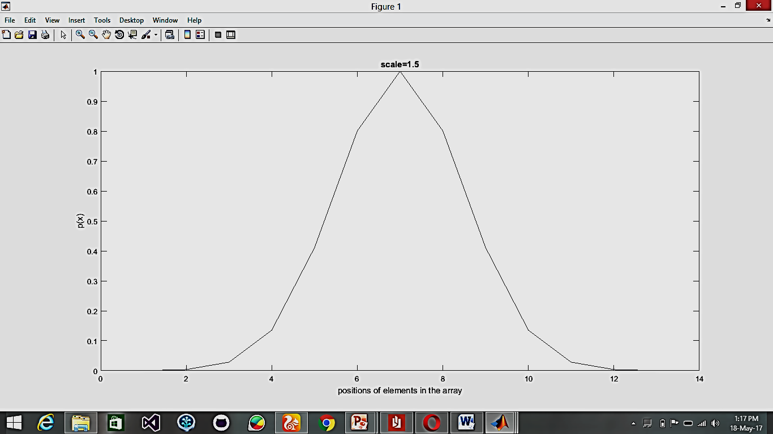

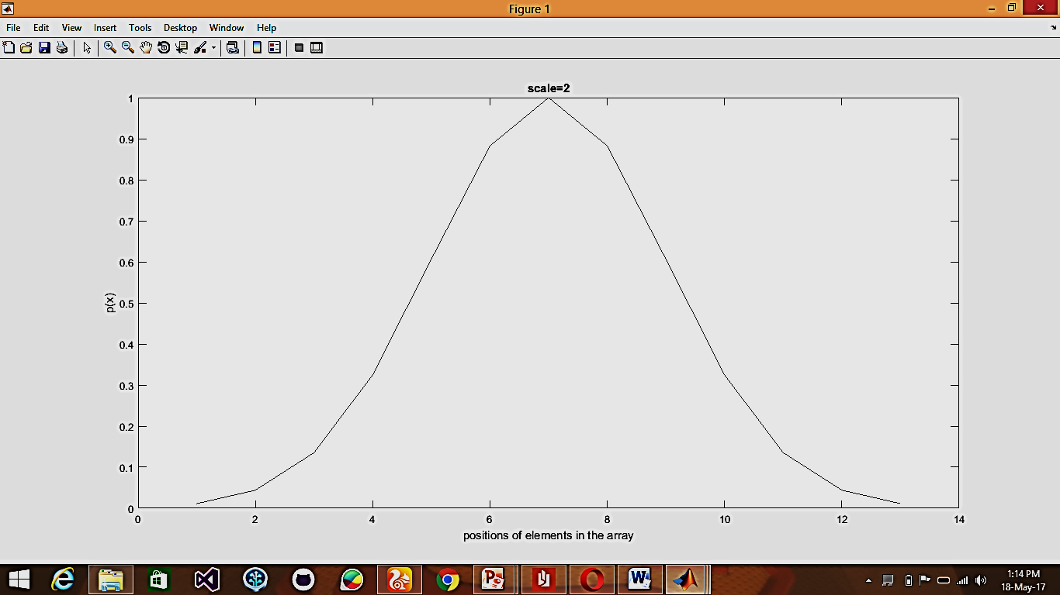

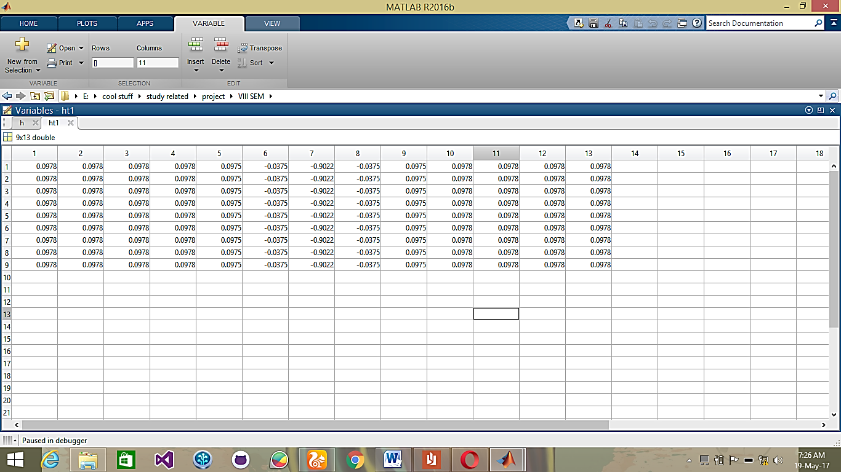

This is the kernel formed without zero padding

FUTURE WORKS

We have planned of a possible modification to our project.



A structuring element will start at any arbitrary point and will go on tracing the curves using the graph theory concept of neighboring pixels which is similar to 8-point connectivity in Image Processing. With this the system should be able to trace out the distance the structuring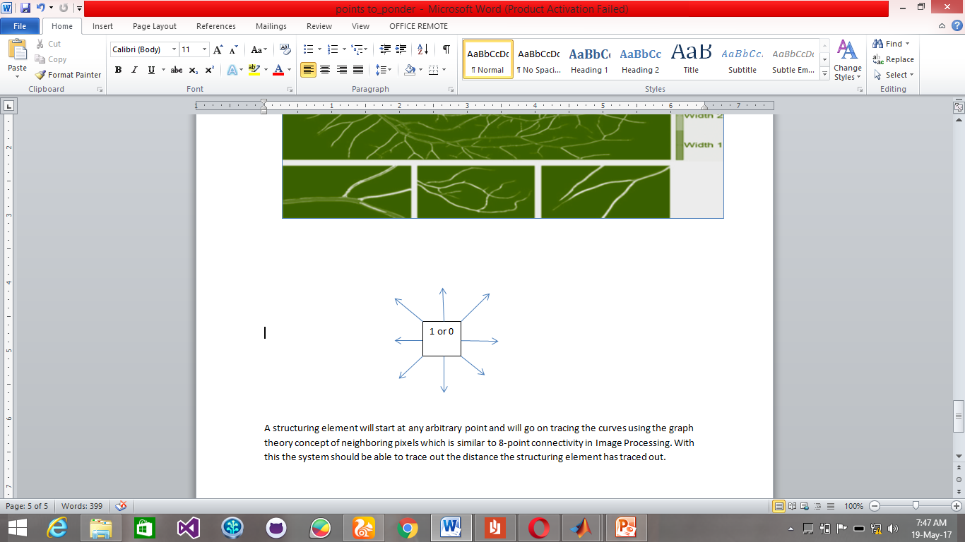 element has traced out.

This is very similar to the google maps when it traces our Destination path from the starting point.